Communications plan template
Ben Wilson (or you)
Date

The glorious image of the glorious comms plan
Table of Contents
Summary 3
Situation or Problem Statement 4
Background 4
Problem statement 4
Opportunity 4
Risks 4
Key metrics 4
Challenges 4
Objectives 4
Examples: 5
Audience 5
Core messages 5
Channel map 5
Plan of action and timeline 6
Plan of action 6
Deliverables 6
Tasks 6
Timeline 6
Feedback and analytics 6
Table for basic recording of numbers, but you probably want something more rich than this 7
Risks / Contingency planning 8
Resources 8

Summary
Introductory paragraph: something like “Recent customer feedback shows that 50% of customers want a simpler and cheaper version of our product. In surveys of customers who choose our competitor’s product, price is mentioned 75% of the time. To maintain market share and access new markets at the same time, we need to develop a more streamlined product.
Supporting points: We can offer a similar product with a lower price if we;
- Trim feature 1
- Expand our available selection in EMEA
- Something else
Supporting paragraph 1 (optional): Summarized strategy and goals
Supporting paragraph 2: Benefits of a cheaper product
Supporting paragraph 3: Implementation timeline

Situation or Problem Statement
The situation section should contain;

Background
A succinct breakdown of the context and background of what you're trying to do here. This provides why you're doing what you're doing.

Problem statement
Straightforward. I have a post on deconstructing problems, but if you need to make a problem statement;
State the core problem - don't state a solution in the problem statement.
Substantiate it with some kind of proof, preferably a number.
Close the problem statement with why it matters to us.

Opportunity
Potentially favorable conditions that could be a competitive advantage. Market research may be helpful, or social research. Depends on what you're doing.

Risks
Kind-of the opposite of opportunities; these are potentially unfavorable conditions that could lead to a loss of competitive advantage, or harm.

Key metrics
"You can only improve what you can measure." Buuuut, don't just SWAG this; this is a great opportunity to tie the comms plan directly to the company bottom line. The more accurate you are, the more you can point at it in the future and say "Look, we did a thing."

Challenges
What things will make it difficult to accomplish your goals?

Objectives
I like to break this down into two sections; Goals and Objectives. Goals are broad, abstract, sometimes qualitative statements on what you hope to achieve. Objectives are more detailed, often quantitative steps to achieve that desired abstract state.

Examples:
Goal: Increase brand loyalty and mind share in the 25-34, upper middle class demographic in the north Denver area.
Objective: Increase followers in the area by 11-13% Y-o-Y and increase engagement rates by 1%.
Note that you don't provide a solution or road map here. This is just the objective/goal segment.

Audience
Do a proper analysis of the other humans you're talking to. Seriously. If you know who you're talking to, you can determine where they're listening and how to talk to them.
Ignoring your audience means losing 1/2 of the value of the conversation. You're putting in the effort to make a comms plan, do it right.
I find that making a table of my audience with as many columns as I need is a good way to put that audience types up front, and then expand on the details of each with a paragraph or two about their needs and behaviors. Uses and gratifications theory is a good one here.

Core messages
Put lists of talking points, key messages, and Q&A in here.
Is there a chance that anyone in your organization might be a point of contact for the press? If so, put info for press contact cards in here. If you aren't the person who educates your staff on press contact protocols, just tell that person that you have some press Q&A content for them.

Channel map
Since you defined your audience, you can figure out what channels to use. Some considerations:
- Are there publicly available data which show the channels and devices your demographic favors?
- Are there political or geographic boundaries that affect which channels penetrate in their area?
- Are there any geopolitical considerations that would affect which channels to use?
- Are there any physical barriers that would affect which channels? I've worked with audiences in geographic areas that had no internet, television, or radio penetration. Not all audiences are the same or have the same access.
- Are there other audiences in the channel or area that you need to be aware of, other than your intended audience?
- Do you have segmentation capabilities to restrict delivery to only one audience?
Be aware of context and noise in your chosen channels. Context is typically cultural, sometimes microcultural; a certain acronym on Reddit may not carry the same meaning on Facebook. Noise is, well, anything that could interfere with your message being decoded accurately enough to elicit the desired action. Psychological, historic, and linguistic barriers are examples of things that can interfere.

Plan of action and timeline
This section needs to have a plan of action and a timeline, and it's not a bad idea to put deliverables in here. It doesn't need to be a full-fledged project plan, but some general ideas are fine. Write it with room for flexibility. I favor open, editable formats for the timeline; tables, sheets, smart art, whatever.
FWIW: Tactics can be used interchangeably here.

Plan of action
Description of the tasks to be accomplished.

Deliverables
You could put a list of deliverables here.

Tasks
You could do the same for tasks.

Timeline
Mapping the above things to a timeline is a great reference point. You’ll look at this a lot.

Feedback and analytics
How do you know that you're doing a good job? This is a good time to dust off your communication models. Specifically, I favor the Osgood-Schramm model for this one:
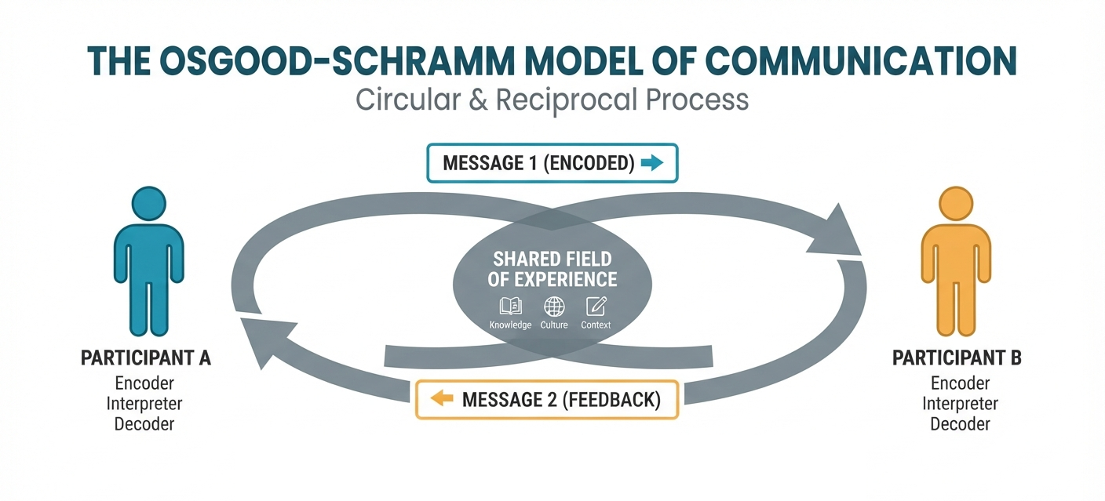
Infographic
Osgood-Schramm model, By Ben Wilson
You, Participant A, encode information to Participant B, who decodes it, then replies in a feedback loop. This tells you some things;
If your strategy is working
How your strategy is affecting emotions and actions
If there are any potential risks on the road (This is called issues management)
That type of feedback provides qualitative data, which is incredibly useful but hard to count. For that, you need quantitative data - Google Analytics, Social analytics, Sentiment analysis numbers, conversions, sales, whatever. Come up with a way to collect all of that data in one place, if you don't already have one. It can be a spreadsheet, a smartsheet, a dashboard, an airtable base, Notion, Qualtrics, whatever. Just put it all in one spot so you can make pretty visualizations for your reports later.

Table for basic recording of numbers, but you probably want something more rich than this

Last but not least:
When you're looking at the entire thing later, don't forget to combine your qualitative and quantitative, and get some insights out of it. 13.1M users in a day means nothing. 13.1M users in one day, followed by 15M users the next, followed by a weekend of +$1M sales W-o-W can make an insight.

Risks / Contingency planning
Put on your red team hat, and think of what could cause your strategy to break down. Then, come up with ways to prevent those events from occurring.
Pro Tip: Want to be fancy? Assign a three color scale to each risk:
- Green for low risk, things that are unlikely to stop the strategy
- Amber (okay, yellow in this case) for medium risk, things that can stop the strategy but not harm the business
- Red for high risk, things that can harm the business
If you're mapping your risks in a spreadsheet or a table, it's usually pretty easy to set conditional formatting. Otherwise, using a block character like █ and changing the text color is a quick way to do it in a word processor.

Resources
This is your bibliography, sources, and contact directory. Keep updating this when things change. The next time you dust this strategy off you’ll be thankful you did.

